05a. Location Center
- General Overview
- Top Section: Button Console & Property Info
- Non-Static Menu Items
- Right-Hand Static Panel

General Overview
Housed on the Tonic server and accessible here, the Location Centre is a highly useful tool for agents. It consolidates comprehensive details about a listing onto a single page, allowing agents to easily research its fraud history, view all reviews removed for fraud, send out fraud letters and much more.
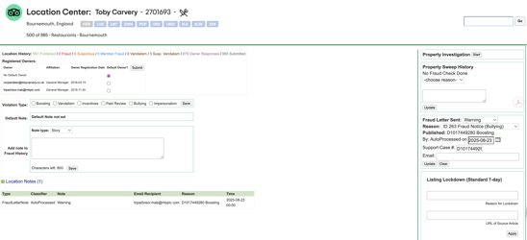

Top Section: Button Console & Property Info
The Button Console allows agents to access the listing on the live site, URD, unfortunately some buttons do not work right now.
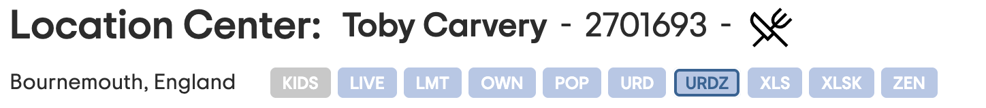
Directly underneath, the LC displays review statistics (Location history): published reviews, fraud removals, suspicious removals, member fraud removals, vandalism removals, suspicious vandalism removals, owner responses, total submitted reviews.
Penalty Information: Featured in a red box at the top right. Note: While we can share expiration dates with owners, we cannot disclose the penalty percentage.
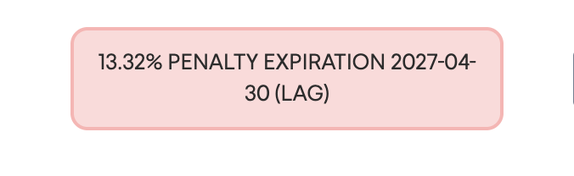

Non-Static Menu Items

Registered Owners
Lists representatives from the Management Center. You can set/reset the Default Owner for official communications by selecting the email address and clicking submit.
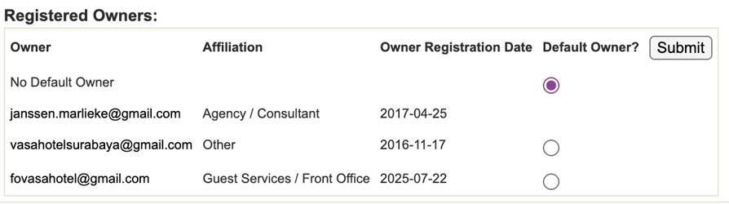

Location Notes
Location Notes are used across all teams to record critical information about a property (for example, verbal complaints regarding user bullying or the reasons behind a Red Badge approval).
- Note type: Use Story by default; Synopsis pins the note to the top.
The Location Notes section archives both manual entries created by agents and records of automated fraud letters sent to a property. Each log displays the:
- Note type (manual vs. system-generated)
- Recipient's name
- Reason for the note
- Exact timestamp of the action
These notes allow us to quickly evaluate a property's history—including past violations, previous behavior, and who was contacted. Additionally, this is the section where the Investigations Team flags whether they intend to handle a specific conversation themselves.
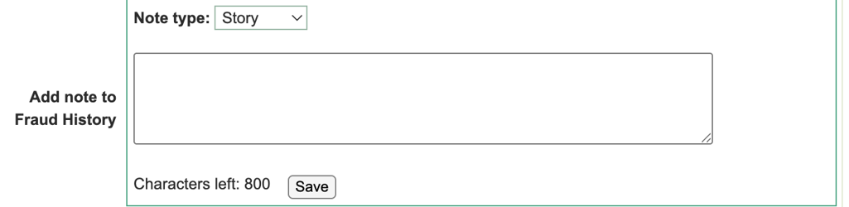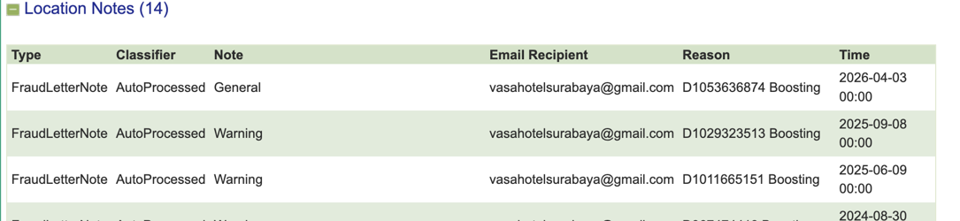

Management Responses
This tab shows management responses submitted by the property.
- Review ID: clickable and links to the URD.
- Submission Info: Date, Email, and IP Address.
- Status: Published or Removed.

Fraud Removed Reviews
This tab shows information about all reviews removed for CI reasons
- Review ID: clickable and links to the URD.
- Details: Review ID, Email, IP, and Rating.
- Removal Note: Comment explaining the manual or system removals.

Vandalisms
Displays reviews removed specifically for vandalizing this property. This does not include vandalism directed at other locations by the property.

Verifications Sent
This tab shows all reviews for this location that have been sent any type of verification email.

Owner Attributes
This tab details the attributes, level, and origin of a user's affiliation with the property. It also allows us to disable specific attributes or email addresses, which is particularly useful for removing unintended affiliations (for example, if a user linked themselves to the property by mistake).

Right-Hand Static Panel

Fraud Letters Sent
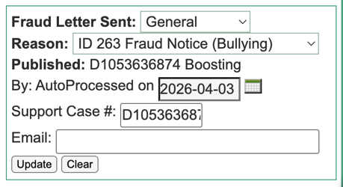
Steps to send a Fraud Letter: Select General > Choose Reason > View Template > Send Email > Update Date.
Important: Never use letters with "Penalty" in the title.

Fraud Penalty
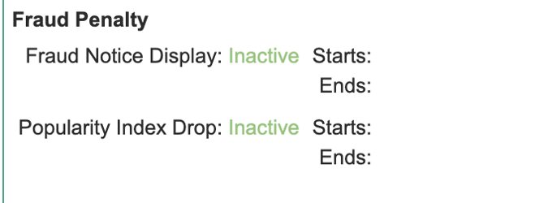
This section of the Location Center is used by the Investigations and Tier 2 teams to publish a Red Badge Warning to a property, which strictly requires prior approval from the Legal Team. Under no circumstances should a Red Badge penalty be applied without this legal clearance. Additionally, Red Badges must not be removed without prior approval from Tier 2 or Investigations.
Active Status: A property with an active Red Badge will display an "Active" status highlighted in red. This section will also show the start and end dates of the penalty, along with the duration of the property's popularity index penalty.
Inactive Status: A property without an active penalty will display as "Inactive" highlighted in green, with no associated start or end dates.

Penalty Mitigation
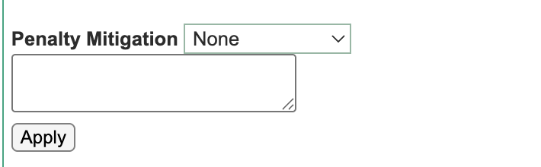
Agents will use this section of the Location Center to manually mitigate a penalty. To do so:
- Select either Full or Standard mitigation.
- Leave a comment that includes the corresponding Zendesk ID.
- Click Apply to finalize the mitigation.
Agents shouldn’t use any other part of the Location Center

